The University of Arizona

Guidelines for Management of HSV Keratitis

Kristina Voss M.D., and Todd Altenbernd M.D.

1. Obtain Pertinent Medical History
2. Prior HSV keratitis
3. Kidney disease
4. Immunosuppression
5. Steroid use
6. Latanoprost use
7. Contact lens use
8. Post keratoplasty
9. Pregnancy or breast-feeding status
10. Exam
    1. Corneal sensation prior to instillation of drops
    2. Characterize the keratitis
       1. HSV keratitis – dendritic (image 9-4)
       2. HSV keratitis – geographic (image 9-7)
       3. HSV stromal keratitis without ulceration (image 9-10)
       4. HSV stromal keratitis with ulceration (image 9-12)
       5. HSV endothelial keratitis (image 9-11)
    3. Dilated fundus exam to rule out acute retinal necrosis

|  |  |  |  |
| --- | --- | --- | --- |
| Corneal Layer | Nomenclature | Alternate Terms | Findings |
| Epithelium | HSV Epithelial Keratitis | Dendritic Ulcer | Punctate epithelial keratitis that may coalesce into 1 or more arborizing dendritic ulcers with terminal buds |
| Epithelium | HSV Geographic Ulcer | Geographic ulcer | Further coalescence of dendrites into larger expansive geographic ulcer |
| Stroma | HSV Stromal keratitis without ulceration | Non-necrotizing keratitis, interstitial keratitis, immune stromal keratitis | Unifocal or multifocal interstitial haze or whitening of the stroma in the absence of epithelial ulceration |
| Stroma | HSV Stromal keratitis with ulceration | Necrotizing Keratitis | Suppurative corneal inflammation, epithelial defect may be eccentric, stromal vascularization |
| Endothelium | HSV endothelial keratitis | Disciform keratitis | Disc shaped stromal edema and keratic precipitates out of the proportion to AC reaction |

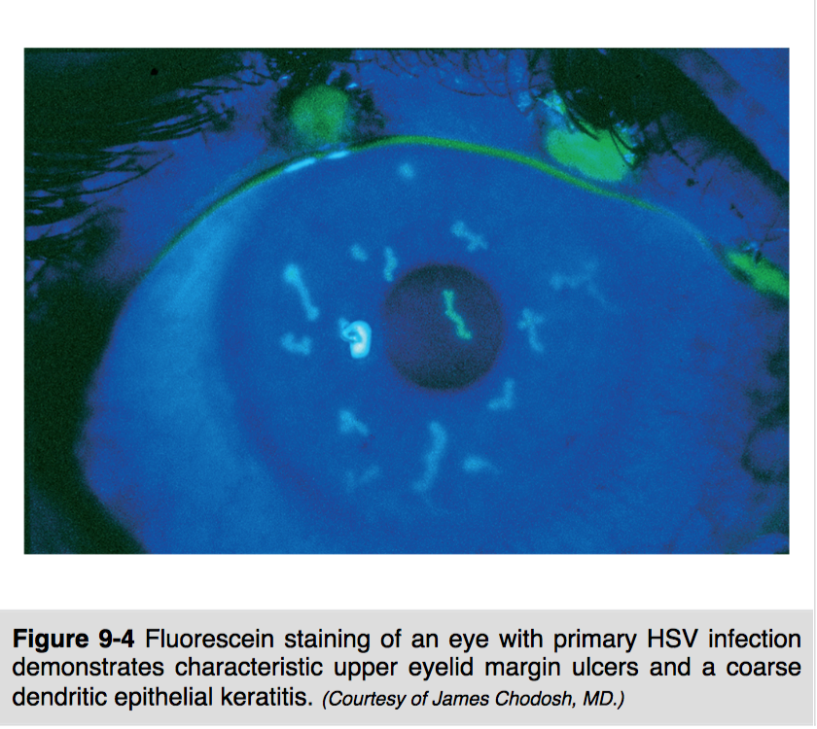 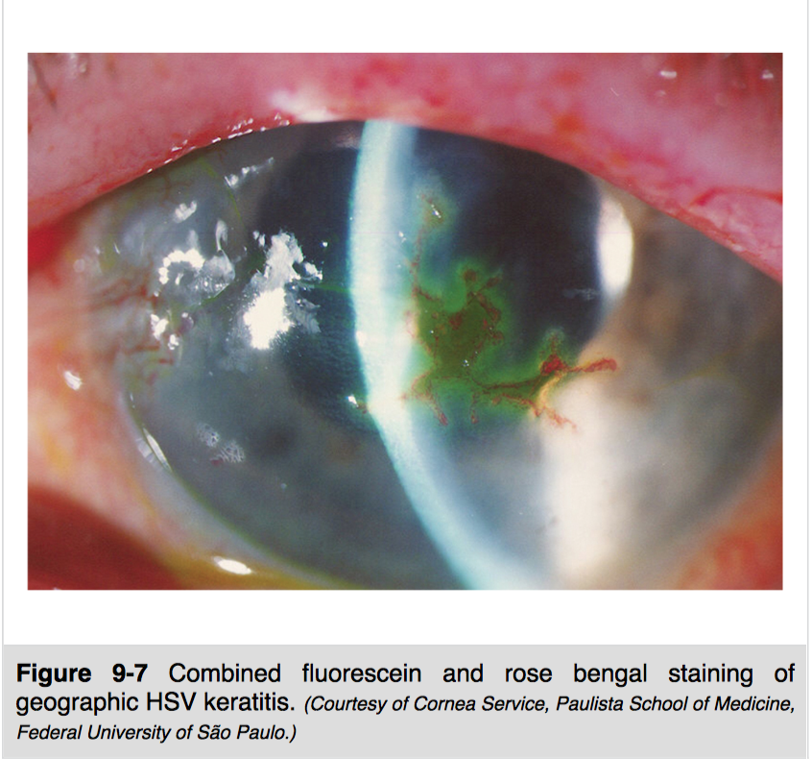 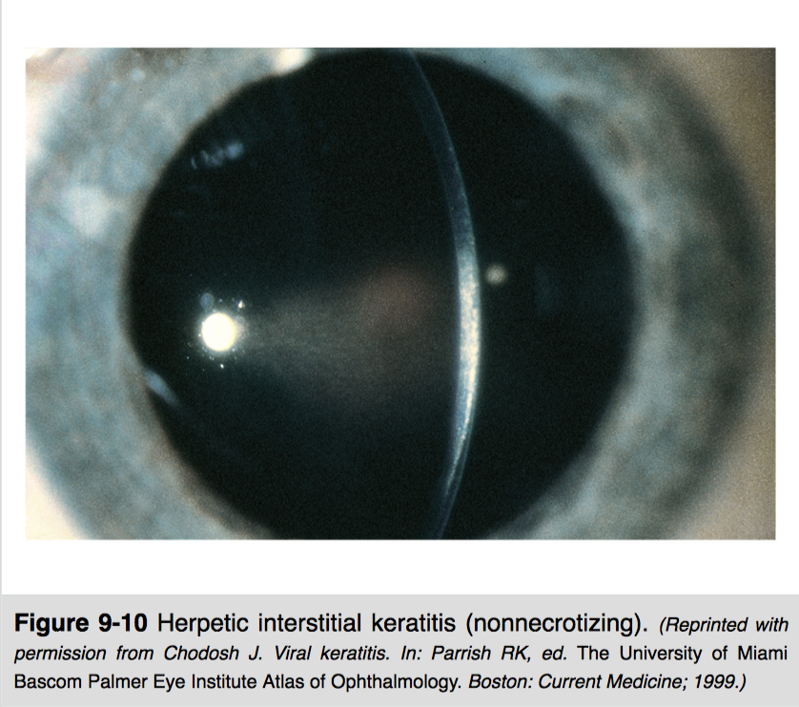

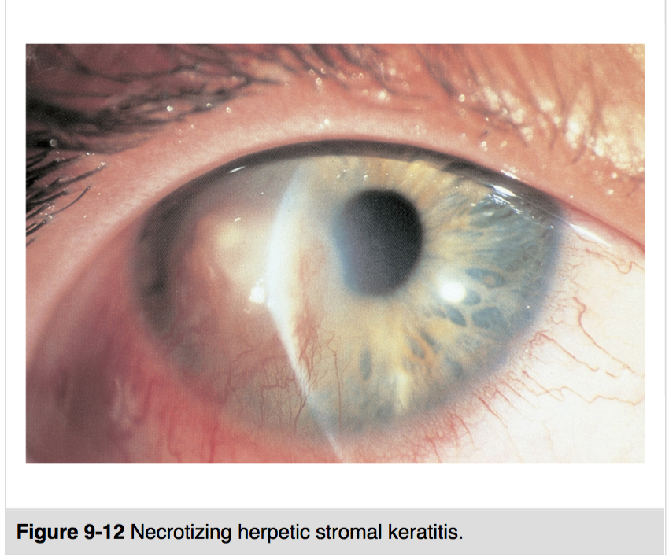 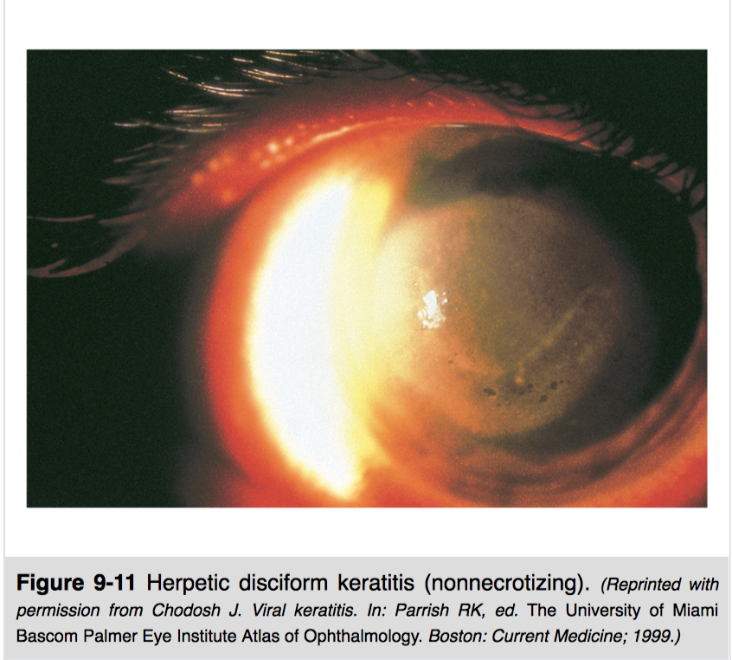

1. Work-up
   1. Diagnosis is based on clinic exam alone
   2. Specific antiviral susceptibility testing may be indicated only in patients with frequently recurrent ocular HSV despite oral prophylaxis or in immunocompromised patients when systemic therapy fails
   3. Check kidney function is patients > 21 years of age if not done within last year
2. Treatment
   1. There are 3 oral and 2 topical agents approved in the US for the treatment of HSV keratitis. **The choice of agent depends on special circumstance (section 5).**
   2. Stop topical and/or oral steroids if able
   3. Stop contact lens use
   4. Stop latanoprost or transition to other ocular hypotensive (cases of hsv keratitis coincident with latanoprost use)
      1. Epithelial Keratitis – dendritic

Therapeutic dose of topical or oral antiviral agent

* + - 1. Acyclovir 400 mg 3-5 x/day for 7-10 days **OR**
      2. Valacyclovir 500 mg 2x/day for 7-10 days **OR**
      3. Famciclovir 250 mg 2x/day for 7-10 days **OR**
      4. Trifluridine 1% 1 drop 9 x/day for 7 days. Do not exceed 21 days due to toxicity **OR**
      5. Ganciclovir gel 0.15% 1 drop 5x/day until healing followed by 1 drop 3x/day for 7 days.
    1. Epithelial Keratitis – geographic

Therapeutic dose of topical or oral antiviral agent

* + - 1. Acyclovir 800 mg 5 x/day for 14-21 days **OR**
      2. Valacyclovir 1 g 3x/day for 14-21 days **OR**
      3. Famciclovir 500 mg 2x/day for 14-21 days **OR**
      4. Trifluridine 1% 1 drop 9 x/day for 7 days. Do not exceed 21 days due to toxicity **OR**
      5. Ganciclovir gel 0.15% 1 drop 5x/day until healing followed by 1 drop 3x/day for 7 days.
    1. HSV Stromal Keratitis without ulceration

Therapeutic dose of topical corticosteroid PLUS prophylactic dose of oral antiviral agent

* + - 1. Prednisolone acetate 1% 6-8 x/day tapered over greater than 1 week **PLUS**
      2. Acyclovir 400 mg 2 x/day at least until completion of steroids **OR**
      3. Valacyclovir 500 mg 1x/day at least until completion of steroids **OR**
      4. Famciclovir 250 mg 2x/day at least until completion of steroids
    1. Stromal Keratitis with epithelial ulceration

Limited dose of topical corticosteroid PLUS prophylactic dose of oral antiviral agent

* + - 1. Prednisolone 1% 2x/day **PLUS**
      2. Acyclovir 800 mg 3-5 x/day for 7-10 days **OR**
      3. Valacyclovir 1 g 3x/day for 7-10 days **OR**
      4. Famciclovir 500 mg 2x/day for 7-10 days
    1. Endothelial Keratitis

Therapeutic dose of topical corticosteroid PLUS therapeutic dose of oral antiviral

* + - 1. Prednisolone 1% 6-8x/day **PLUS**
      2. Acyclovir 400 mg 3-5 x/day for 7-10 days then 400 mg 2x/day at least until steroid course complete **OR**
      3. Valacyclovir 500 mg 2x/day for 7-10 days then 500 mg 1/xday at least until steroid course complete **OR**
      4. Famciclovir 500 mg 2x/day for 7-10 days then 250 mg 2x/day at least until steroid course complete

1. Special Circumstances
   1. Renal Impairment
      1. Prefer topical antiviral to oral due to nephrotoxicity
      2. May be appropriate to use oral antiviral with renal adjustment (see chart at [AAO HSV Guidelines](https://www.aao.org/clinical-statement/herpes-simplex-virus-keratitis-treatment-guideline)) or with guidance from nephrologist
   2. Immunocompromised Patient (HIV, Transplant, etc)
      1. Prefer Famciclovir
      2. Valacyclovir and Acyclovir have warnings of increased risk of TTP/HUS in patients with immunosuppression HOWEVER they have been demonstrated to be safe and effective in 3 RCCTs and may be appropriate to use in certain circumstances
   3. Neonate
      1. Must Use IV antiviral due to higher risk of fatal encephalitis or disseminated disease
      2. Consider IV acyclovir 60 mg/kd/day in 3 divided doses (discuss with neonatologist prior to starting)
   4. Pediatric Patient
      1. Oral agent easier to administer than topicals
      2. Should be weight adjusted, no clear guideline on dose
      3. Acyclovir approved for ages > 2 but likely safe and effective in neonates and above (also available in suspension)
         1. Oral doses should not exceed 80 mg/kg/day (3200 mg/day)
         2. Consider treatment dose range 12-80 mg/kg/day in 3 divided doses
         3. Consider prophylaxis dose range 12-20 mg/kg/day
      4. Valacyclovir safe and effective for children greater than age 2
      5. Famciclovir contraindicated (only patients >18 years)
      6. Trifluridine approved for ages 6 and older
      7. Ganciclovir approved for ages 2 and older
   5. Pregnant or Woman of Child-Bearing Age
      1. Prefer topicals over orals even though all orals are pregnancy category B and all topicals are pregnancy category C
      2. Consider using topicals and recommending punctal occlusion
      3. Acyclovir or Valacyclovir may be appropriate
   6. Elderly Patient (>65 years of age)
      1. Famciclovir preferred as acyclovir and valacyclovir carry increased risk of CNS adverse reactions and renal failure in elderly patients
      2. Consider topicals
   7. Recurrent Keratitis
      1. Prophylaxis indications:
         1. Multiple recurrences of any types, especially stromal keratitis
         2. Recurrent inflammation with scar/vascularization encroaching visual axis
         3. More than one episode of HSV keratitis with ulceration (this is a strong stimulus for corneal vascularization and lipid deposition)
         4. Post-keratoplasty performed for HSV-related scarring
         5. Post-operatively in patients with a history of HSV ocular disease undergoing any type of ocular surgery or laser procedure
         6. In patients with a history of ocular HSV during immunosuppressive treatment
      2. Prophylaxis options:
         1. Acyclovir 400 mg 2x/day for at least 1 year OR
         2. Valacyclovir 500 mg 1x/day for at least 1 year OR
         3. Famciclovir 250 mg 2x/day for at least 1 year

Optimal duration has not been determined

* 1. Lactose Intolerance
     1. Lactose-free brand oral antiviral agents
        1. Zovirax (acyclovir) 400 or 800 mg (200 mg contains lactose
        2. Valtrex (valacyclovir)
  2. Cost Conscious (see scale, values from GoodRx current as of 2018)
     1. Acyclovir $ 400 mg pid x 10 days ($11.77)
     2. Valacyclovir $ 500 mg bid x 10 days ($13.33)
     3. Famciclovir $ 500 mg bid x 10 days ($21.30)
     4. Trifluridine (Viroptic) $$ 7.5 ml bottle = 21 day course q2hr ($64.49)
     5. Ganciclovir (Zirgan) $$$$$ 5 gm 2 week course ($337.61)
        1. Unable to obtain prior-authorizations over the weekends for viroptic or zirgan . Additionally, these medications often require

the pharmacy to order the medications and will take 2+ days. Generic acyclovir is the most likely to be in stock.

1. Follow up
   1. Within 1 week

Cost Scale

$ = 0-50 dollars

$$ = 50-100 dollars

$$$ = 100–200 dollars

$$$$ = 200–300 dollars

$$$$$ = 300-400 dollars

Adapted from

1. Herpes Simplex Virus Keratitis: A Treatment Guideline. Michelle Lee White, M.D., M.P.H., and James Chodosh, M.D., M.P.H. Massachusetts Eye and Ear Infirmary Department of Ophthalmology Harvard Medical School. May 2014.

Images from

1. AAO Basic Clinical Science Course External Disease and Cornea. 2018-2019. Robert W. Weisenthal, MD.

Additional Sources:

1. Bert, Benjamin. How to Manage Pediatric Herpes Keratitis. Review of Ophthalmology. Nov 7, 2017.
2. GoodRx. October 2018.